**Tooltip for Salesbuddy**

This SOP guides Area Business Managers (ABMs) and Regional Business Managers (RBM) on how to utilize tooltips on the SaleBuddy website's landing page to access information related to the number of stores on tack, stores that need nudge and the stores that need push this is available for both ABM’s and RBM’s

**Process Overview:**

To view the tooltips displaying the number of stores on track, needing a nudge, or needing a push, follow these steps:

**Step1:** **Go to the Landing Page:**

- Goto landing page of salesbuddy website.

**Step2: Keep the Mouse Over a Section:**

**-** Keep your mouse pointer over the relevant section without clicking.

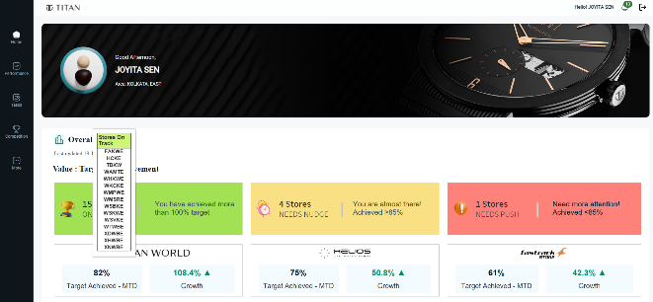





**Step 3: View Store Information:**

As you hover over the section, a tooltip will automatically appear, displaying relevant information about the stores within that field. This information typically includes:

- The number of stores that are currently “on track”.

- The number of stores that may “needs nudge".

- The number of stores that "needs push".

The tooltip will list the store names based on their work state within the selected section.